**Creating a Google Ad**

Previously, you learned about Google Ads and the different types of Google Ad formats. This reading will provide an overview of the seven steps to creating a responsive search ad based on your stated objective.

These instructions are based on the Google Ad interface, which offers guidance along the way.

You can opt to create a campaign without defining a goal for guidance by selecting the option when presented on screen.

**Seven steps to create a Google Ad campaign**

**1. Define your campaign goal**

Your goal is what you want to achieve with the ad. There are seven campaign objectives to choose from:

* **Sales:** drives sales online, in app, by phone or in store
* **Leads**: brings in leads and other conversions by encouraging customers to take action
* **Website traffic:** encourages people to visit your website
* **Product and brand consideration:** encourages people to explore your products or services
* **Brand awareness and reach:** reaches a broad audience and builds awareness
* **App promotion:** increases installs or promotions for your mobile app
* **Local store visits and promotions:** encourages customers to visit a physical store location

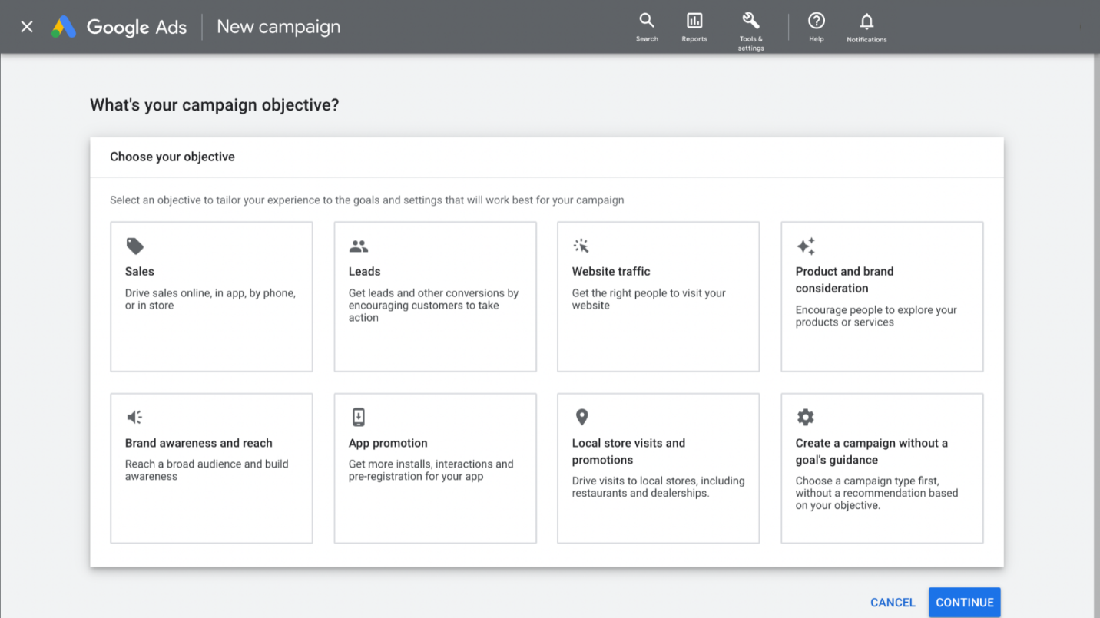

**2. Choose the campaign type**

Next, choose your campaign type. Options include:

* Search
* Performance Max
* Display
* Shopping
* Video
* Discovery

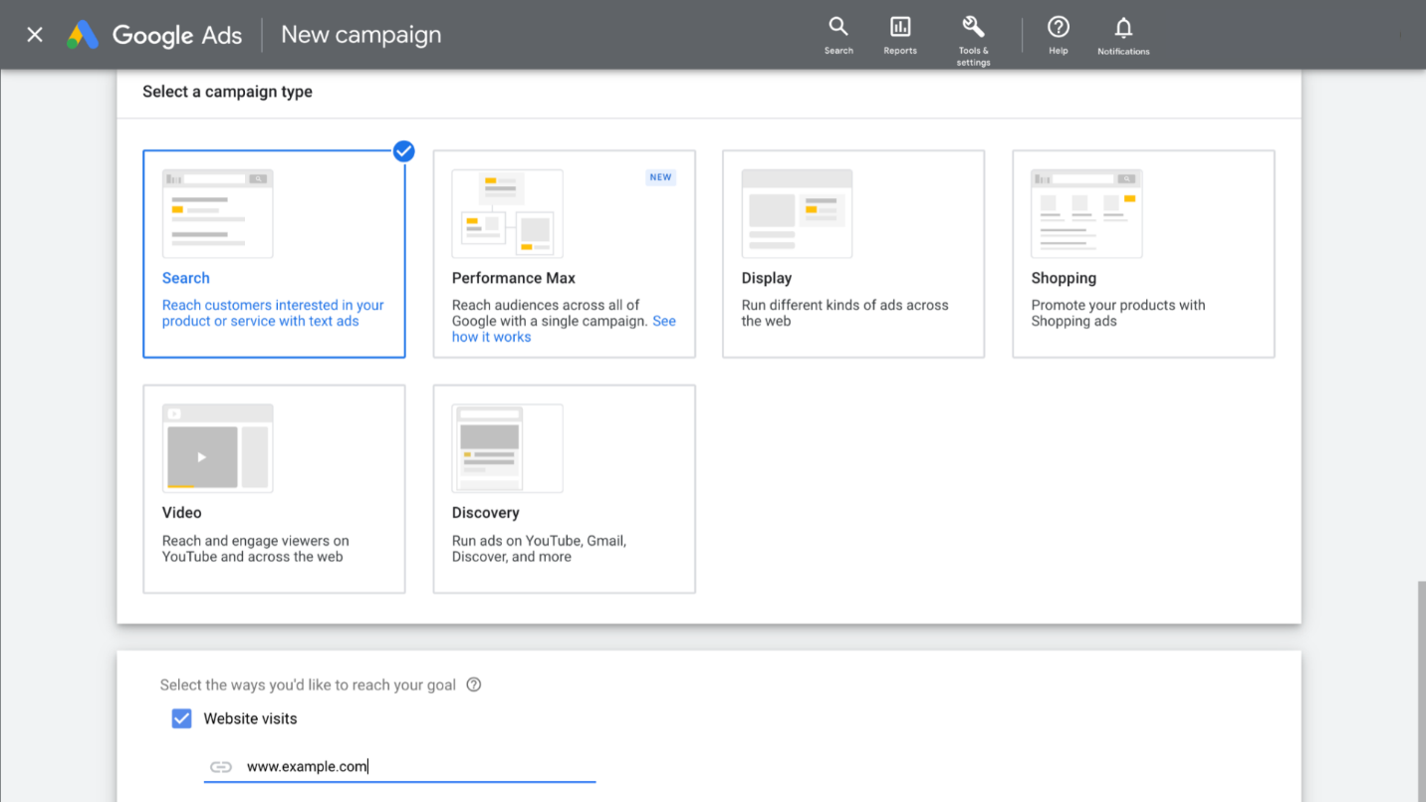

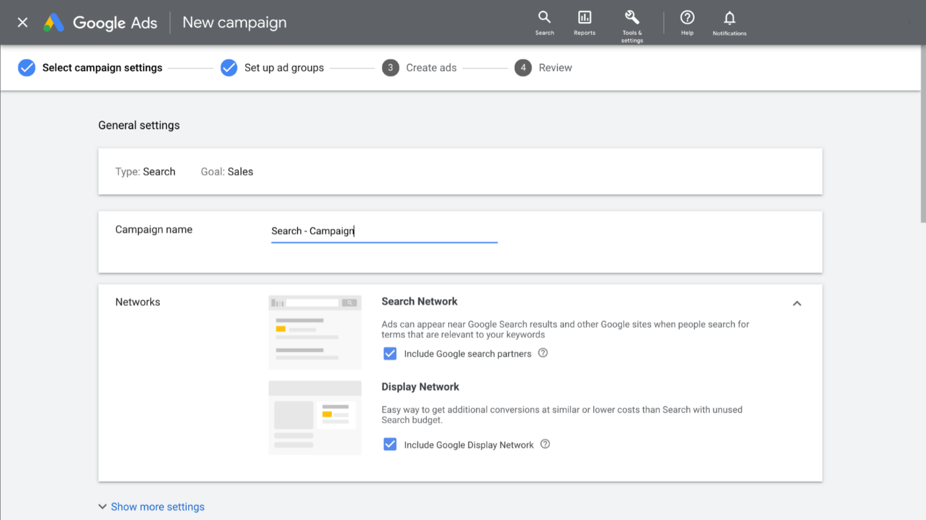

**3. Set a budget**

Once you select your campaign, move on to set your budget. For more information on setting your budget, visit the [Google Ads Help Center](https://support.google.com/google-ads/answer/2375420?hl=en&co=GENIE.Platform%3DDesktop).

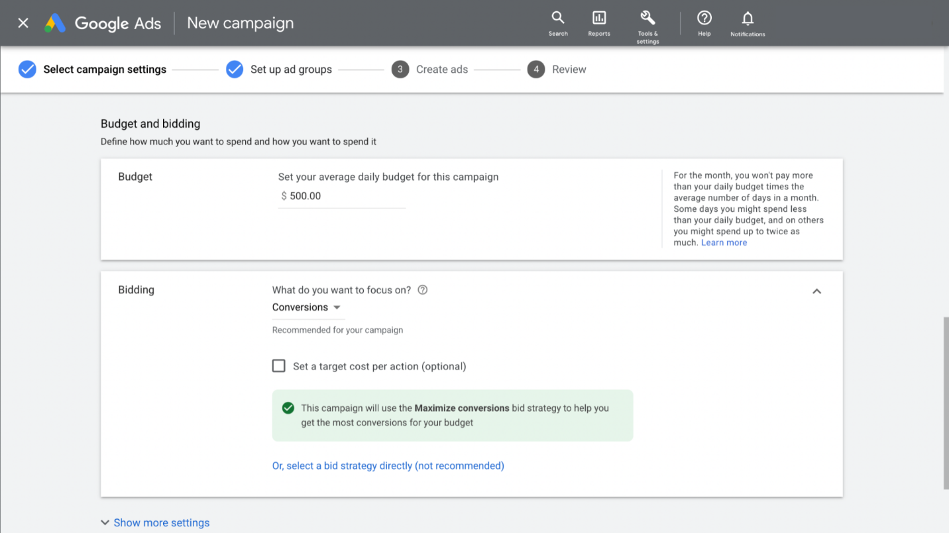

**4. Choose your bidding strategy**

Refer to a [previous reading](https://www.coursera.org/learn/digital-marketing-ecommerce-first-course-2/supplement/fvXdj/google-ads-bid-strategies) on bidding strategies to review the different types.



**5. Select your targeting**

Targeting helps define how narrow or broad your audience targeting will be. Your target categories include:

* Locations
* Languages
* Audience segments

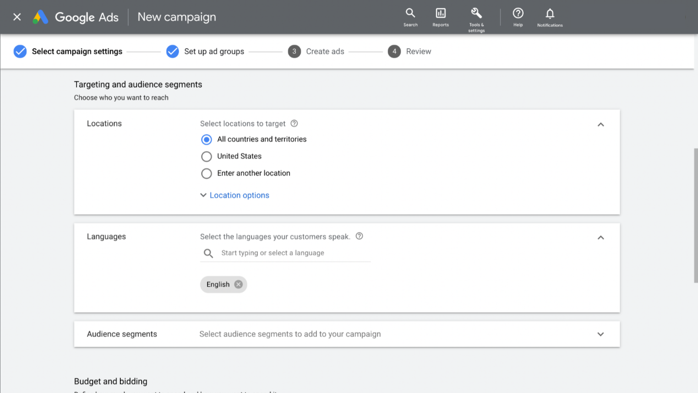

**6. Create your ad**

To create your ad, input information to determine how your ad will appear online. This includes:

* Descriptions
* Final URL
* Display path
* Headlines
* Extensions

Be sure to include at least one of your keywords in your headlines, and create headlines that are relevant to the keywords you’re targeting. Also, use the ad strength indicator as a guide to improving the effectiveness of your ads. Ad strength provides you with feedback to help you focus on providing the right messages to your customers.

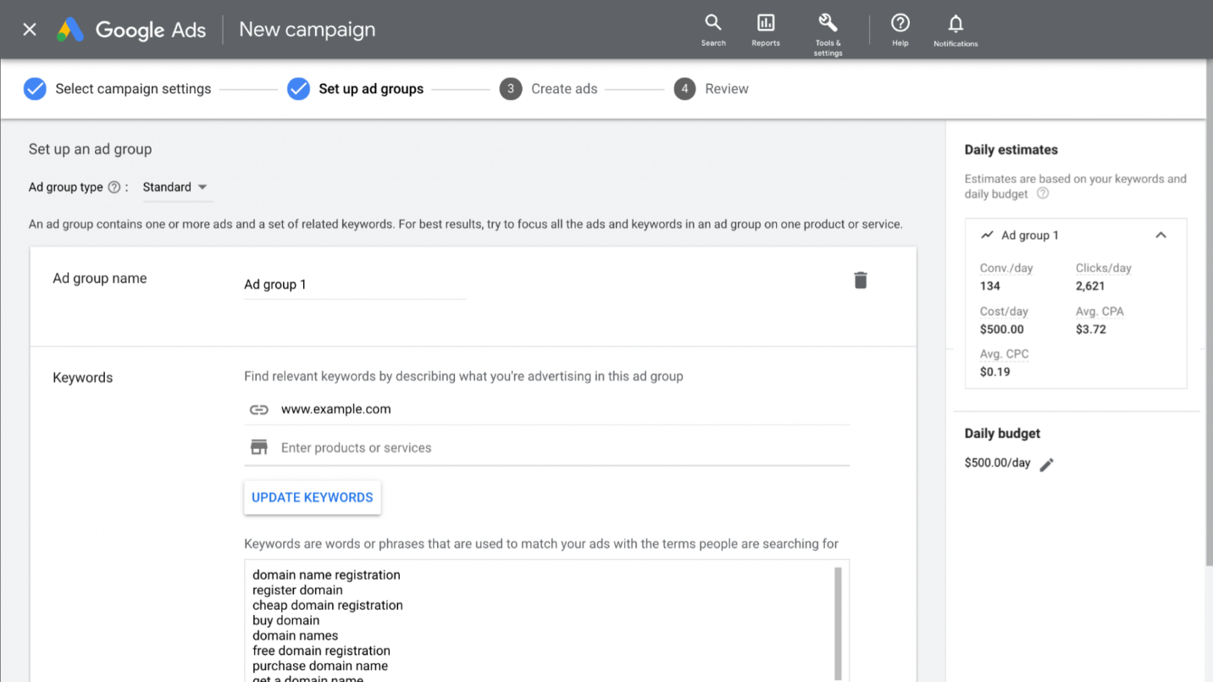

**7. Finalize your ad**

Once you are ready, finalize your ad by adding your final URL and display path. Use the preview window on the screen to check how your ad will appear online.

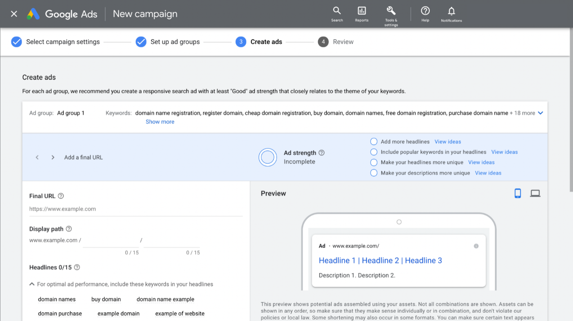

**Resources for more information**

For more information on creating a google ads campaign, visit the following resources:

* [Create effective Search ads](https://support.google.com/google-ads/answer/6167122): This Google Help center article provides information for optimizing ads and messaging on Google Search.